Data Storytelling Guide: What, Here’s What, So What, Now What
Use this worksheet to walk through the 4-step process for turning data into meaningful stories. Each step includes space to write your responses.
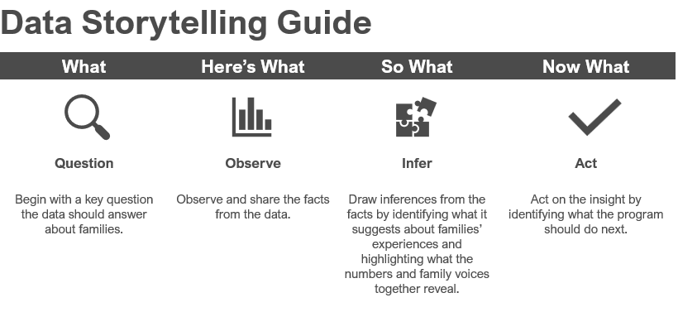
Before You Begin: Identify Your Data Source
- Where is the data coming from? (e.g., surveys, interviews, administrative data, case notes)
Data Source
 | Step 1: What (Question)
- Begin with the key question the data should answer about families.
- Specific to one program area or activity
- Open-ended (more than yes/no or a number, asks “how” or “in what ways”)
- Focused on family outcomes, not just numbers
Write your open-ended question

 | Step 2: Here’s What (Observe)
- Observe and share the facts from the data.
- Summarize totals, averages, and family voices.
Numbers
Family Quotes & Stories

 | Step 3: So What (Infer)
- Break down your interpretation into three parts: numbers, family voice, & meaning.
So What: Write Your Narrative – Numbers
Summarize the numbers (totals, averages, counts)

So What: Write Your Narrative – Family Voice
Summarize what families are saying (quotes, themes)

So What: Write Your Narrative – Infer Meaning
What do the numbers and voices together suggest?

So What: Write Your Narrative
- Bring it all together! Use the space below to draft a short narrative that combines your question, predictions, facts, insights, and actions into one cohesive story.

Step 4: Now What? (Act)

Act on the insight by identifying why it matters for families and what the program should do next.
Internal Actions
External Actions

